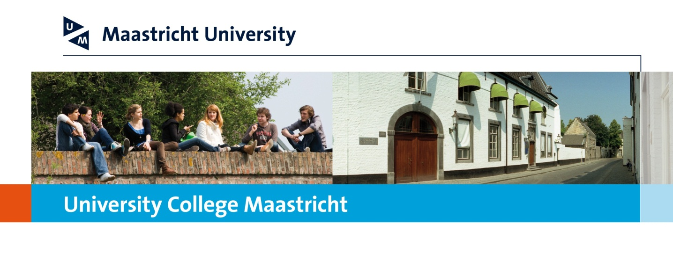

**OVERVIEW UCM PARTNER UNIVERSITIES**

**Last update: October 2024**

**Outside Europe:**

|  |  |
| --- | --- |
| Australia | * Monash University, Melbourne * The Australian National University, Canberra * The University of Adelaide, Adelaide * The University of New South Wales, Sydney * The University of Queensland, Brisbane * The University of Sydney, Sydney * The University of Western Australia, Faculty of Arts and Faculty of Science, Perth |
| Botswana | * The University of Botswana, Gaborone |
| Brazil | * Pontificía Universidade Católica do Rio de Janeiro (PUC Rio) |
| Canada | * Queen’s University, Kingston, Faculty of Arts and Science * Simon Fraser University, Vancouver, Faculty of Arts and Faculty of Sciences * L’Université de Montréal, Montréal |
| Chile | * Pontifica Universidad Catolica de Chile, Santiago |
| Ecuador | * Universidad San Franciso de Quito |
| Hong Kong | * The Chinese University of Hong Kong * The City University of Hong Kong |
| India | * Ashoka University |
| Japan | * Waseda University, School of International Liberal Studies * Doshisha University, Institute for Liberal Arts |
| Mexico | * Universidad Iberoamericana, Mexico City, Dept. of Psychology, Dept. of Philosophy and Bachelor of Political Science and Public Administration * ITESM, Tec de Monterrey |
| New Zealand | * The University of Waikato, Hamilton |
| Peru | * Universidad del Pacífico, Lima |
| Singapore | * Singapore Management University |
| South Korea | * Korea University, Seoul * Seoul National University, Seoul * Yonsei University, Seoul |
| Taiwan | * National Taiwan University, Taipei |
| USA | * American University, Washington D.C. * George Washington University, Washington D.C. * Hobart and William Smith Colleges, Geneva, New York * Middlebury College, Middlebury, VT * University of California, Berkeley, Davis, Irvine, Los Angeles, Riverside, San Diego, Santa Barbara and Santa Cruz campus * University of Connecticut, Storrs, Connecticut * University of Maryland, University Honors College, College Park, Maryland * University of Richmond, Virginia * University of Vermont, Honors College, Vermont * University of Washington, Honors Program, Seattle, Washington |
| **In Europe:** | |
| Finland | * University of Helsinki, Faculty of Social Sciences |
| France | * l’Institut d’Études Politiques, Toulouse * l’Institut d’Études Politiques, Lille |
| Germany | * University College Freiburg * Double Degree Program with University College Freiburg |
| Italy | * Luiss Libera Università Internazionale degli Studi Sociali Guido Carli, Roma |
| Norway | * University of Oslo, Faculty of Social Sciences |
| Poland | * University of Warsaw, Faculty of “Artes Liberales” |
| Slovac Republic | * Bratislava International School of Liberal Arts, Bratislava |
| Spain | * Universidad Carlos III, Madrid, School of Humanities and School of Law and Social Sciences * Universidad de Salamanca, Facultad de Ciencias Sociales * IE, |
| Turkey | * Bogazici University, Department of Sociology, Istanbul * Bilkent University, International Relations and Political Sciences, Ankara |
| United Kingdom | * King’s College London, Department of International European Studies * Leeds University, School of Politics and International Studies * University College London, Arts and Sciences * University of Exeter, Flexible Combined Honours Programme * University of Sussex * University of York |